## RESEARCH SYSTEMS EXERcise

1

Explain differences between JavaScript Expressions and Angular Expressions?( 3 mins)

e..g. void operator is not allowed in Angular expression, coma is not allowed.

In Javascript context is evaluated against the window object where as in angularjs the context is evaluated against the scope object

In Javascript when we try to evaluate undefined properties generates a Reference error, In angularjs expression evaluation is forgiving to undefined or null

Angular js allows filters within the expressions

We cannot declare functions inside angular expressions

We cannot use new operator in an angular expressions

2

Explain difference between factory and service in AngularJS? (2 mins)

Factories are the functions that return the object, while services are constructor functions of the object, which are instantiated with the new keyword

3

Please take the attached JSON file and write a nodeJs or Java service/server side function to read the data and sort it by Symbol, Transaction type and Transaction id. The output should be stored in a file. (45 mins – 1 hour)

4

Please read the output of the exercise 3 above and show it in a responsive grid (Table structure) like below? (45 mins – 1 hour)

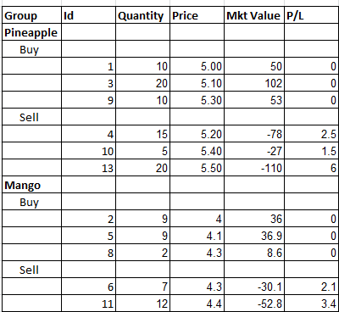

5

Use the output from the exercise 3 above and write a function to compute profit and loss for each sell transaction based on the First in First out for Pineapples.

P/L = Sell price * Sell Quantity – Buy price * Buy Quantity

Please show the output as a column on the grid/table displayed in exercise 4. (45 minutes to 1 hour).